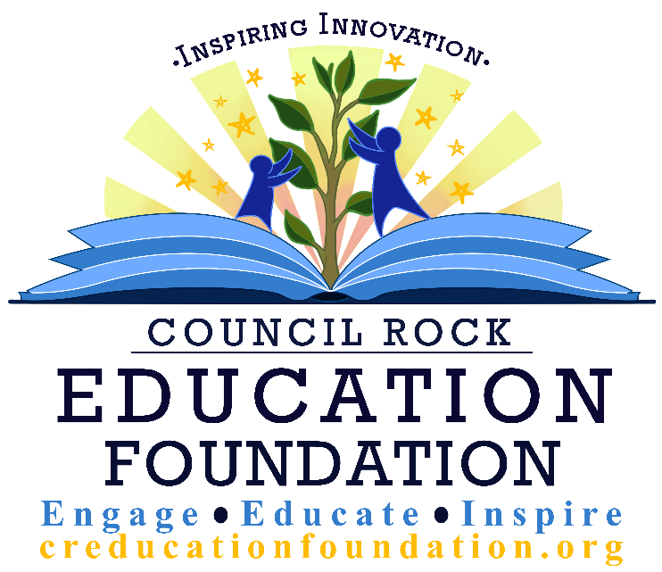

Innovative Learning
Grants

2018 Grant Guidelines

For programs to be implemented in the 2018-2019 school year

Grant Deadline: March 2, 2018

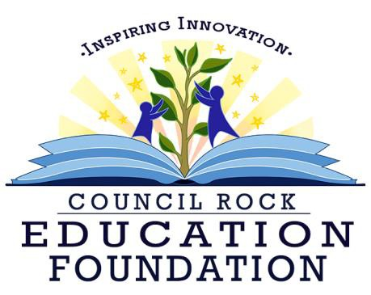

Innovative Learning Grants

The Council Rock Education Foundation (CREF) is pleased to provide grant funds to teachers and staff of the Council Rock School District through the Innovative Learning Grans Program. The Foundation Board will award grants for projects that enhance and enrich the district’s curriculum and public education.

What is CREF? The Council Rock Education Foundation is a nonprofit organization created to encourage excellence and to enhance and enrich educational opportunities offered to the students of the Council Rock School District. The Board of Directors consists of business professionals, community members and school district personnel. The Superintendent of Schools and a member of the School Board are voting members of the Council Rock Education Foundation.

Our Mission: The Council Rock Education Foundation partners with the community, businesses, and the Council Rock School District to provide inspiring programs and innovative learning grants to enhance the educational experience of all district students.

What is an Innovative Learning Grant? CREF resources are distributed to support programs for the benefit of the students in the Council Rock School District. The Foundation, acknowledging that teachers and educators of the Council Rock School District are the best equipped to recognize, organize, and support such programs, has created the Innovative Learning Grants (ILG) program.

ILG projects may be limited to a single classroom, involve several grade levels or departments, or they may be school/district-wide.

EITC Funded Programs
CREF is an approved Educational Improvement Organization (EIO) under Pennsylvania’s Educational Improvement Tax Credit (EITC) program. As an EIO, the Foundation receives donations from area businesses that in turn receive tax credits for their donations. Applications supported under Direct EITC Funded Projects are restricted to state-approved categories and must be innovative in nature.

Innovative Learning Grants - 2018 Guidelines

Submission Deadline: March 2, 2018
The purpose of the Council Rock Education Foundation grant is to enhance and support innovative programs for the benefit of the children in the Council Rock School District.

Who can apply?
  - All Council Rock staff
  - Community organizations
  - PTO/PTA/Home and School Association

How much can I ask for?
Grant Requests will be accepted up to $5,000. To see examples of previously awarded grants go to www.creducationfoundation.org. Please make sure to anticipate any cost increases and sales tax and include those in your budget projections. The Foundation will not cover any costs that exceed the amount granted. Since product prices can increase between the time of the application (March) to the time of purchase (after July 1) we strongly recommend that applicants ask vendors to disclose any expected cost increases and include those in your budget. In the unfortunate chance that grantees expenses exceed the grant amount, they have several options to locate additional funds:
- School Principal
- Department Chair Budget 3. Curriculum Coordinator

Can grants be used to purchase technology/equipment?
Projects that include the purchase of technology/ equipment will be considered only if use of this equipment is integral to innovative instructional strategies. The technology/equipment must be clearly described in the grant narrative and properly listed with accurate costs given within the budget. All proposed technology/equipment purchases will be submitted to Matt Frederickson for approval before being considered for funding.

Can grants be used for travel?
Travel expenses will only be considered when they represent less than 10% of the project budget and only if the travel is essential to the project’s success. Overnight travel expenses are not eligible for grant funding.

What additional information should accompany the application?
Projects that require outside presenters or personnel must include resumes and/or
organizational information about the presenters.

Projects that require equipment purchases (items over $500) must include a brief description of the equipment as well as supporting documents (catalogues, etc.)

- Why are the principal's signature and curriculum coordinator’s signature required on the grant application? The principal's signature is an assurance that supporting and sustaining resources will be available for the project and that it poses no conflict with the school's established curriculum. A principal can often be a great help in making a teacher's application more cost effective, since portions of the required resources may already be available through the school district's general fund or through other organizations such as the PTA's. The curriculum coordinator’s signature is an assurance that the project is in line with the current and planned curriculum objectives for the district.

Reporting and Award Requirements
  - State Reporting – Under the EITC guidelines, CREF must provide end-of-year reports substantiating that the projects met the approved categories for funding.

  - Grantees are required to submit final reports that will be used in CREF’s end-of-year report. The Executive Director of the Education Foundation will contact recipients to provide report forms and assure the reports are submitted in a timely manner.

  - All grant recipients will be asked to provide a calendar of implementation and to be available to showcase grants throughout the year in various formats including district professional development

Submitting the Application & Application Requirement:
All of the following are required as part of a complete grant application. There is a grant checklist within the grant application itself to serve as a reminder of these requirements.
- The completed application must be submitted no later than midnight on March 17, 2017. Neither applications nor application materials will be accepted after that time. Grant applications are to be emailed to the CREF ILG Committee, crefgrants@googlegroups.com. No extensions beyond the deadline will be granted.
- Applications should be completed online or e-mailed as a single document in PDF format to the Grant Committee at crefgrants@googlegroups.com. Submission should be titled in the following format: LastName_BriefDescriptionofGrant.pdf (Example: Smith_Garden.pdf). Please note:
  - All school personnel applications must be signed and dated \ by both the applicant(s), building administrator and curriculum coordinator in order to be considered.

  - If more than one school is involved, each building administrator must sign the application.

  - If applicant(s) is/are not Council Rock staff members, contact Gail Acosta at gacosta@creducationfoundation.org if you need information about obtaining signatures.

- Funding for special technology or equipment, such as iPads or laptops, is only applicable when clearly an integral part of an innovative grant program proposal. All proposed technology and technology purchases over $500 are subject to approval from Matt Frederickson. The CREF ILG Committee will present any Technology applications to Matt for approval prior to the grants committee meeting in April.
- For grant proposals including equipment/technology requests, all supportive technical information and/or technical specifications are required and must accompany the grant application as a PDF file. No hard copies will be accepted.

Review Criteria:
Please note that this is a competitive grant process, not all grants submitted will be funded. Applicants are reminded to provide a thorough narrative that clearly describes their project and answers all questions. Incomplete grant narratives, no matter how worthy the project, will not be funded.

In evaluating the applications, the grants panel will consider the following criteria:

- Summary – Is the project clearly described? If restricted funds are requested, does the applicant explain how the project relates to the funding category? Is there a sequential listing of activities with dates and timeframe listed where appropriate?

- Student Learning Outcomes – Does the application concisely explain specific student learning outcomes that are based on specific needs? Does the language used in the outcomes contain phrases such as “The student will…”? Are methods for evaluating student learning outcomes described?

- Evaluation – How will the overall effectiveness of the project be measured? What are the expected benefits of the project? For multi-year and continuing projects, what evaluation data is available and how has this data been used to adjust and/or justify project continuance?

- Curriculum Based – Is the project innovative and enriching? Does the application specify how this project uses an innovative and enriching approach to teaching and learning? What is the relationship of the project to the CRSD curriculum and standards that best fit the project?

- Long Term Impact – Does the application describe follow-up activities for the students, teachers and/or staff?

- Budget – Does the budget reflect reasonable, efficient use of funds? Do expenses reasonably support the project goals? Is there a provision within the budget for partial funding of project expenses? Is project sustainable after initial CREF funding?

- . Completeness of Application – Is all required documentation submitted in PDF format?

Grant Program Timeline:
March 2, 2018- Deadline for submitting grant application
March 5-15, 2018 - Grant panel meets to review application and make recommendations to the CREF Board
March 26, 2018 – CREF Board approves grants. Grant awards announced in May
April 2018 – Grant award ceremony at CRSD Board Meeting

Budgeting time to write the grant
It is important for teachers and administrators to plan their projects far enough in advance to submit their applications by the March 2, 2018 deadline. Late applications will not be accepted. Applicant questions may be asked of the ILG Committee at gacosta@creducationfoundation.org

12. . Provide phone number and best times to be reached.

13. When must funds be expended?
All funds will are designated for projects planned for the 2018-2019 school year and must be expended between July 1, 2018 and June 30, 2019. All use of funds must comply with CRSD Purchasing Guidelines. Funds not expended by the stated deadlines will be returned to CREF and will be reallocated by the CREF ILG Grant Committee and Board of Directors. The maximum funding level for applications is $5,000

************************************

All materials and equipment awarded through the grant process become the property of the Council Rock School District. CREF reserves the rights to any profits generated from future distribution or production of any CREF funded end product. This includes any proceeds from marketing a CREF funded end product by CREF or the entity receiving funding.

Thank you for your interest in innovative educational programs through the Council Rock Education Foundation! If you have any specific questions about the grant or Foundation, please contact Gail Acosta, Executive Director, at 215-944-1023 or gacosta@creducationfoundation.org

PROGRAM AREAS

The Council Rock Education Foundation considers programs in the following main areas:

STEM Innovation

Providing advanced educational programs to increase students’ knowledge of and hands on experience in the areas of Science, Technology, Engineering and Math.
Recently funded programs include:
Science: Family Science Night; Let’s Build a Molecule, iPad Astronomy, Robotics Academy, Solar Suitcases Technology: Blended Classroom, App Development for Mobile devices, Interactive Videoconferencing, Senteo Interactive Response System
Engineering: Rock Rovers NASA project, Egyptians and Engineering
Math: Dreambox Math

Environmental Engagement

Providing value-added programs that engage students to identify. investigate and propose innovative solutions to environmental issues both locally and globally. Recently funded programs include: Council Rock Green Team, Trout in the Classroom, Organic Gardening

Youth Leadership and Community Engagement

Developing students’ leadership skills by engaging with community organizations to study and address issues ranging from bullying and mentoring to historical and geographical issues connected to racial, class, and power divides. Recently funded programs include: Camp Ophelia, Peer Mentoring Program, ILS Annual Friendship Day, Census Past and Present, Tales of the Towpath

Arts and the Creative Economy

Providing students innovative new ways to explore and develop their creativity in music and art programs contributing to awareness of the impact that creativity can have upon all aspects of our economy. Recently funded programs include: “I”-Motion Claymation; Makerbot 3D Sculpture, Digital Portfolios, Short Film series, Sculpture Garden, Reawakenings of American Indian Music, Fabric Art.

21st Century Literacy

Creating opportunities for students to access, analyze, evaluate and communicate messages in a wide variety of forms through innovative literacy programs. Recently funded programs include: Read to Succeed, iPads for RTL Reading, Mindful Metacognition, Canine Assisted Learning Program, Electronic Language Learning for ESL.

Health and Wellness

Providing creative opportunities for students to explore, create and apply health and fitness to their everyday lives. Recently funded programs include: Multimedia Fitness, HIV/AIDS Elementary Curriculum Kits

Special Needs

Providing innovative learning programs to enhance and expand the skills and opportunities for our special needs students. Recently funded programs include: Green Team Autism Club, Kids with Heart, Inclusive Practices and the Friendship Bracelet project.

